National University of Computer and Emerging Sciences, Lahore Campus

 | Course: | Data Structures and Algorithms | Course Code: | CS210
 | Program: | BS (Electrical Engineering) | Semester: | Fall 2018
 | Assessment Tool | Programming Assignment # 1
 | Total Marks: | 50

PROBLEM CLO [3]

Consider the following grid, where the first row and column represent the coordinates:

 | 0 | 1 | 2 | 3 | 4 | 5 | 6
0 | 0 | 0 | 1 | 1 | 1 | 1 | 1
1 | 0 | 0 | 1 | 0 | 1 | 0 | 0
2 | 0 | 0 | 1 | 0 | 1 | 0 | 0
3 | 0 | 0 | 0 | 0 | 1 | 0 | 0
4 | 1 | 1 | 1 | 1 | 1 | 1 | 0
5 | 1 | 0 | 0 | 0 | 0 | 0 | 0
6 | 1 | 0 | 0 | 0 | 0 | 1 | 1
7 | 1 | 1 | 0 | 0 | 0 | 1 | 1
8 | 0 | 1 | 1 | 1 | 0 | 1 | 1
9 | 0 | 1 | 1 | 1 | 0 | 1 | 1
10 | 0 | 0 | 0 | 0 | 0 | 0 | 0
11 | 0 | 0 | 0 | 0 | 0 | 0 | 0
12 | 0 | 0 | 0 | 0 | 0 | 1 | 1
13 | 0 | 0 | 0 | 0 | 0 | 1 | 1

Suppose a robot has to find a path from a starting point to a fixed goal point. Zero means it’s a forbidden cell and 1 means its allowed to go into that cell. You have to find the correct path through allowed cells to reach the goal. For example in the above if (0,2) is the start state and (9,3) is the goal state then one possible path is given by the blue highlighted cells. A simple algorithm for finding this path is given by:

- goalFound=false
- current = start
- stateStack.push(current)
- repeat
{
- stateStack.pop(current)
- if current == goal then goalFound = true
- else
{
  - Generate possible next states from current using actions {up,down,left,right} and store them in nextstatesArray provided the next state has not been visited before
  - push every item of nextstatesArray on the stateStack
}

}
until (stateStack is empty OR goalFound)
return goalFound

An example of how this program runs is:
current | statesStack
 | (0,2)
(0,2) | (1,2)  (0,3)
(1,2) | (2,2)  (0,3)
(2,2) | (0,3)
dead end
(0,3) | (0,4)
(0,4) | (1,4)  (0,5)
(1,4) | (0,5)
AND SO ON….

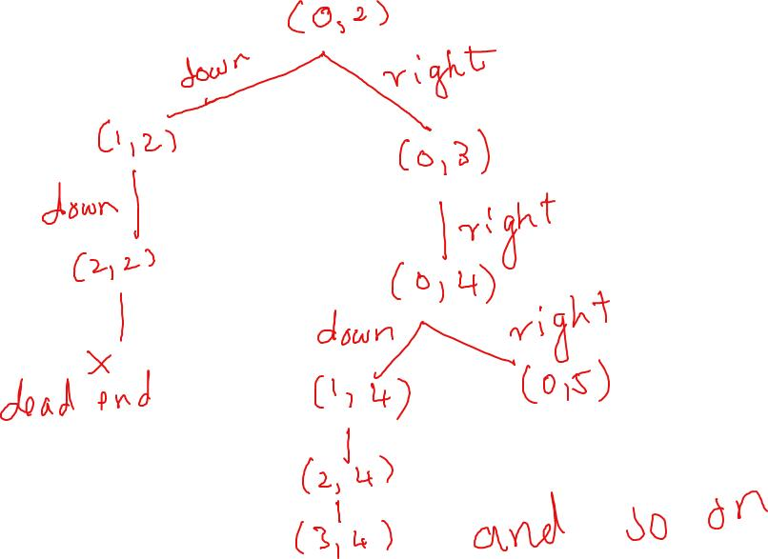

FORMAT OF INPUT FILE
An example is given in grid.txt and the function to read the file is implemented
totalRows totalColumns
start state
goal state
the grid

YOU HAVE TO:
- Implement the stack template
- Implement the above algorithm
- Add to the above algorithm so that it prints all the visited states in the same order that they are visited by using a stack
- Add to the above algorithm to find the exact path, so for example for the above problem it should print the path highlighted in blue
- The code for this problem is partially provided to you and you simply have to write the functions specified in the C++ files provided
- The program has to read the grid, start state and end state from the file. Sample code is provided to read the grid.
- The found path has to be written to a file called ‘path.txt’
- The visited states have to be written to a file called ‘visited.txt’

Submission Guidelines:
You are allowed to do this assignment in a group of 2 students. Archive your files (.h and .cpp) in a zip file named as your roll number(s). Upload this file on slate under the assignment submission section till Thursday 25th October 11am.
Please hand me the hardcopy of the assignment in next class. Code should be documented and well written in C++. It must compile.

VERY IMPORTANT
Academic integrity is expected of all the students. Plagiarism or cheating in any assessment will result in negative marking or an F grade in the course, and possibly more severe penalties.

